

South East Cornwall Multi Academy Regional Trust

SMART Admission Arrangements for

2027/28

Adopted by the Trust Board: 3rd November 2025

Contents
Introduction 3
Applying for a place 3
Allocation of places 3
Deferred/delayed entry to primary school 4
Admission of children outside their normal age group 4
Oversubscription criteria 5
Tie-breaker (except for sixth forms applications) 6
Final tie-breaker 6
Admission to sixth form 6
In year admissions to sixth form 7
Oversubscription to sixth form 7
Tie breaker specific to sixth form applications 7
Appeals 7
Waiting lists 8
Designated areas 8
Professional Recommendation 9
Siblings 9
Multiple birth siblings 10
Distances 10
Home address 10
Help and advice 11

Introduction
SMART is the South East Cornwall Multi Academy Regional Trust and is the Admission Authority for the following academies:
- Dobwalls Community Primary School
- Landulph Primary School
- Liskeard School and Community College
- Looe Community Academy
- Saltash Community School
- Trewidland Primary and Pre-School
All academies in SMART will participate fully in Cornwall Council’s Fair Access Protocol and the Cornwall Council’s Co-ordinated Admissions Schemes for starting school, secondary school transfer and applying for a place during the school year.
Details of these schemes are available on Cornwall Council’s website or on request from Cornwall Council (all contact details are at the end of this document).
Closing dates and other details about the application process will be stated in those schemes.

Applying for a place
All applications for places at the start of Reception, Year 3, Year 7 or during the academic year must be made to the applicant’s home Local Authority on the appropriate application form.
The application form and supporting information will be available electronically on Cornwall Council’s (or your home Local Authority’s) website.
There is no supplementary information form required by the Trust.
However, if your child has an Education, Health and Care Plan (EHC Plan), you do not need to complete an application form as a school place will be identified through a separate process. Please contact the Statutory SEN Service for more information:
Tel: 01872 324242 Email: statutorysen@cornwall.gov.uk
Please note that if a request has been made for an EHC needs assessment for your child, or your child is currently being assessed to decide whether an EHC Plan is necessary, you will need to make an application using the normal process.

Allocation of places
Children with an EHC Plan that names an academy in SMART will be admitted regardless of the number on roll in the year group.
Children in Care who are directed to an academy by the Secretary of State will be admitted to the academy regardless of the number on roll in the year group.
In the case of admission into Reception Year of a primary academy, attendance at a particular nursery class or an early years provider does not give a pupil any priority within the admissions policy for admission to any primary academy. Parents/carers must still submit an application for a place in Reception Year.
The published admissions number (PAN) for the year of entry (Reception Year and Year 3 in primaries and Year 7 in secondaries) for each of the academies in the MAT in 2027/28 will be as follows:
Academy | PAN 2024/25
Saltash Community School | 230
Liskeard School and Community College | 210
Looe Community Academy | 122
Landulph Primary School | 12
Dobwalls Community Primary School | 30
Trewidland Primary and Pre-School | 10

Places will be allocated up to this number in 2027/28.
In the event that more applications are received than places available, the oversubscription criteria listed in this document will be used to decide on allocations.
If an academy is not oversubscribed, all applicants will be admitted.

Deferred/delayed entry to primary school
All children are entitled to start school full-time in the September following their fourth birthday.
However, parents may choose deferred or part-time entry to the Reception Year for their child, bearing in mind that by law children have to be in full-time education by the start of the term following their fifth birthday; this is when they reach compulsory school age.
Parents of summer-born children (those born between 1 April and 31 August) may also seek a place for their child outside their normal age group i.e. entry to Reception Year a year later than normal, for example if the child may naturally have fallen into a lower age group if it were not for being born prematurely.
If you wish to ask for part-time admission, you must do so as soon as possible after receiving your notification of a place; you can request that your child attends part-time until they are of compulsory school age.
Places in Reception Year will be allocated as full time from September.
Parents choosing part-time or deferred entry or wishing to delay entry to the Reception Year must contact the academy’s Headteacher/Head of school.

Admission of children outside their normal age group
Parents may seek a place for their child outside their normal age group, for example, if the child is considered to be gifted and talented or has experienced problems such as ill health.
Those wishing to request placement outside the normal age group should contact the academy’s Headteacher/Head of school.
Such requests will be considered by the admission authority on a case-by-case basis and in the best interests of the child concerned. Where a child has an Education, Health and Care plan the decision rests with Cornwall Council.
Guidance is available from Cornwall Council’s website or on request from Cornwall Council’s School Admissions Team.
Parents who are refused a place at an academy for which they have applied have the right of appeal to an independent admission appeal panel. However, they do not have a right of appeal if they have been offered a place and it is not in the year group they would like.

Oversubscription criteria
In the event of the number of applications for places in Reception Year or Year 7 being higher than the PAN for the 2027/28 academic year, or where there are more in-year applications than places in any year groups during the school year, the following oversubscription criteria will be used to prioritise applications, after the admission of children whose EHC Plan names the academy:
- Children in care or children that were previously in care but immediately after being looked after became subject to an adoption, child arrangements, or special guardianship order including those who appear (to the admission authority) to have been in state care outside of England and ceased to be in care as a result of being adopted.

- Children who live within the designated area of the academy (see appendix 1 and 2), or whose parents/carers can provide evidence that they will be living in the designated area of the academy by the beginning of the autumn term of the 2026/27 academic year.

If there are more designated area children wanting places at the academy than there are places available, criteria 3 to 7 below will be used to decide which of these children should have priority for admission.
If there are still places available after all the designated area children have been allocated places, criteria 3 to 7 will be used to decide which of the remaining children should have priority for any spare places.
- Children with siblings who will still be attending the academy at the time of their admission.

- For secondary admissions, children on the roll of a primary school (at the time of allocation) whose designated area is contained within, or forms part of, the designated area of the secondary academy.

- Children of all staff employed by SMART (where either or both of the following circumstances exist):

  - Where the member of staff has been employed at the academy to which the child is applying, for two or more years at the time at which the application for admission is made, or
  - Where the member of staff is recruited to fill a vacant post within the academy to which the child is applying, for which there is a demonstrable skill shortage.

- Children with an unequivocal professional recommendation from, for example, a doctor, school medical officer, educational psychologist or education welfare officer that placement at the academy would be in the best interest of the child. Such recommendations must be made in writing, giving fully supported reasons and will be reviewed by Cornwall Council.

- All other children.

Tie-breaker (except for sixth forms applications)
If any of the criteria outlined above leave more children with an equal claim than places available, priority will be given to the child who lives nearer to the academy (see Distances below).

Final tie-breaker
Should the tie-breaker above still leave children with an equal claim because distances are exactly the same, random allocation will be used to decide on priority. The academy will use Cornwall Council’s Random Allocation Protocol, supervised by an independent person, which is available on request.

Admission to sixth form
Our academies with sixth forms also admit pupils from other schools. Their published admission numbers are:
Sixth form | Sixth form admissions 2025/26
Saltash Community School | 30
Liskeard School and Community College | 30

The entry requirements and over-subscription criteria for Year 12 admissions are listed below.
Queries regarding sixth form admissions should be directed to the academy in the first instance.
Admissions are subject to minimum entry requirements for the courses chosen and the total number of guided learning hours required for sixth form study across SMART. The same minimum entry qualifications will also apply to external applicants, as well as those continuing from Year 11 in the academy.
Please see the academy’s sixth form prospectus for details of the minimum entry requirements for each of the courses offered. The sixth form prospectus is available on the academy’s website.
The diversity of courses and opportunities available to sixth form pupils means that not all of the same conditions apply to each course or sixth form centre.
Applicants should check the specific requirements of the course and centre to which they are applying. The following requirements may be necessary in some cases:
Some courses require letters of application to be completed.
Some courses require five GCSE qualifications at grade 5, grade C or higher.
Some courses require the applicant to attend an interview with the Head of Sixth Form or Deputy Head of Sixth Form within which alternative courses may be offered which are deemed more suitable, or with more secure availability. This can happen, for example, if a course attracts too few applicants to be viable and so alternatives need to be considered.

In year admissions to sixth form
Late entry (following the Autumn Census in early October) is not normally permitted to the sixth form except in exceptional circumstances. Please contact the academy for details.

Oversubscription to sixth form
Where the number of eligible external applicants exceeds the places available, the same over-subscription criteria as for all pupils joining an academy in SMART will be used to prioritise applications, after the admission of children whose EHC Plan names the academy.

Tie breaker specific to sixth form applications
If any of the criteria outlined above leave more children with an equal claim than places available, priority will be given to the aptitude of the child, as expressed in references received from their previous school or employer.

Appeals
Applicants refused a place at an academy have the right to appeal. Appeals are heard by an independent appeals panel [arranged by Cornwall Council on behalf of the Governing Board]
Further details and a timeline can be found in Cornwall Council’s Co-ordinated Admissions Scheme. Applicants can only appeal again for a place in the same school within the same academic year if the admission authority for that school has accepted a further application because there has been a significant and material change in the circumstances of the parent or carer, child or school (e.g. a change of address into a school’s designated area), but has determined that the new application must also be refused.

Waiting lists
If an academy is oversubscribed, a waiting list will be held by Cornwall Council for the whole of the academic year of entry.
The waiting list will be based on the school’s oversubscription criteria and a child’s place on a waiting list is subject to change according to additional information received about applications or children being added to the list – so their place on the list might move up or down.
No priority is given to the length of time that a child has been on the list.
Any child with an EHC Plan, or children in care or children that were previously in care and those allocated a place in accordance with a Fair Access Protocol, will take precedence over those on a waiting list.

Designated areas
Cornwall Council has divided the county into geographical areas for primary and secondary schools.
Each of these areas are served by a specific school, or in some cases, groups of schools.
These areas are called ‘designated areas’ (previously referred to as ‘catchment’ areas).
The designated area used in our Trust’s oversubscription criteria will be as defined by Cornwall Council and any entitlement to home to school transport will be based on these areas.
Your designated school will not always be the one nearest to your home address. See map for all designated areas.
If you are planning to move into the designated area of an academy, your application for a place for your child at that academy will not be given the priority accorded to designated area pupils without firm evidence of your new address and moving date, such as a copy of a signed and dated tenancy agreement or confirmation that contracts have been exchanged.
Secondary academy in SMART | Primary academies/ schools in their designated areas
Saltash Community School | Landulph Primary School  Sir Robert Geffery’s School  Burraton CP School  St Stephens CP School  Bishop Cornish CofE Primary School  Brunel Primary & Nursery Academy  St Germans Primary School
Liskeard School and Community College | Braddock CofE Primary School  Darite Primary Academy  Dobwalls Community Primary School  Liskeard Hillfort Primary School  Menheniot Primary School  St Cleer Primary School  St Martin’s C of E Primary School  St Neot Community Primary School  Trewidland Primary and Pre-School
Looe Community Academy | Duloe C of E School  Looe Primary Academy  Pelynt Primary Academy  Polperro Primary Academy  Trenode Primary School

Children with an unequivocal professional recommendation
Children with an unequivocal professional recommendation will only be considered under this criterion where the parent/carer can demonstrate that only the preferred academy can meet the exceptional medical or social needs of the child, supported by a recommendation from, for example, a doctor, school medical officer, educational psychologist or education welfare officer.
Such recommendations must be made in writing to the Cornwall Council School Admissions Team and must give full supporting reasons.
The admission authority will make the final decision on whether or not to accept an application under this criterion.

Siblings
‘Siblings’ means brothers or sisters.
They are defined as children with at least one natural or adoptive parent in common, living at the same or a different address.
Children living permanently in the same household at the same address would also be counted as siblings, regardless of their actual relationship to each other.
To qualify as a sibling a child must be on the roll, or due to be on the roll, of the academy in question at the date of admission.

Multiple birth siblings
If a child is a sibling of a multiple birth (e.g. twins, triplets, etc.) and has been offered a place at the requested academy, every effort will be made to offer places at the same academy, which may mean allocating places above the PAN where that is possible.
However, where this is not possible, parents will be invited to decide which of the children should be allocated the available place(s).

Distances
Home to the academy distances used for tie-breaking will be measured by a straight-line measurement. This will either be:
- outsourced to Cornwall Council using a straight-line measurement, as determined by Cornwall Council’s nominated Geographical Information System - measurements will be between the pupil’s registered home address (centre of the main building) and the main gate of the academy (as decided by Cornwall Council);
The same system will be used by an academy for all admissions in 2027/28.
Distances used to calculate the nearest academy with an available place (i.e. where it is not possible to offer a place at the academy), and for establishing transport entitlements, will be measured by the nearest available route, as determined by Cornwall Council’s nominated Geographical Information System software.

Home address
Each child can have one registered address only for the purposes of determining priority for admission and transport entitlement. The address must be:
• the child’s principal permanent residence at the point of application and the address from which they will attend school; or
• a future address from which the child will attend school, supported by a form of evidence from the list in Cornwall Council’s Co-ordinated Admissions Scheme.
An admission authority may refuse to accept an address if an applicant still owns or rents an address at which their child previously lived. It is for the admission authority to determine:
• if the address given on an application is a child’s current or future principal permanent residence and the address from which they will attend school; and
• which address should be used to determine eligibility for a place.
Exceptional circumstances in relation to the provision of a home address will be considered on a case by case basis. If there is shared residence of the child or a query is raised regarding the validity of an address, the home address will be considered to be with the parent with primary day to day care and control of the child. Residency of a child may also be clarified through a child arrangement order where it is shown who has care of the child. Evidence may be requested to show where the child resides.
It is expected that parents will submit only one application for each child. Any disputes in relation to the child’s home address should be settled before applying, the admission authority will not become involved in any parental disputes. If agreement cannot be obtained before an application is made then parents/carers may need to settle the matter through the courts. Where no agreement is reached or order obtained, Cornwall Council will determine the home address.
For information on disputes between persons with parental responsibility in relation to school preferences please see Cornwall Council’s Co-ordinated Admissions Scheme for the relevant year.
Applications for children of Service Families will be processed and places allocated based on the proposed address (with supporting evidence) or, if the family are not able to confirm a proposed address and a unit or quartering address is provided, an allocation will be made based on the unit or quartering address. Until a fixed address is available, the unit postal address or quartering area address will be used to determine allocation of a school place. For the purposes of measuring distances, the main entrance of the unit will be used.

Help and advice
Should you have any queries, please contact either the academy to which you will be applying for a place, or the Cornwall Council School Admissions Team.
Contact details for Cornwall Council
Cornwall Council  Get help with your application | New County Hall  Treyew Road  Truro  Cornwall  TR1 3AY  School Admissions Team  School Transport  SEN/EHCP  Family Information Service | 0300 1234 100  0300 1234 101  0300 1234 100  01872 324242  0800 587 8191 | Website  www.cornwall.gov.uk  www.cornwall.gov.uk/admissions schooladmissions@cornwall.gov.uk  www.cornwall.gov.uk/schooltransport  statutorysen@cornwall.gov.uk

Contact details for your home Local Authority for those that reside outside of Cornwall
Apply via your home Local Authority | Search online for the “School Admissions Team” within your home Local Authority

Contact details for our SMART academies
Dobwalls Community Primary School | Dobwalls  Liskeard  Cornwall  PL14 4LU | 01579 320527 | Email  Head@dobwalls.cornwall.sch.uk  Website  https://www.dobwalls.net/
Landulph School | Landulph  Saltash  Cornwall  PL12 6ND | 01752 845572 | Email  Head@landulph.cornwall.sch.uk  Website  www.landulph.net
Liskeard School and Community College | Luxstowe  Liskeard  Cornwall  PL14 3EA | 01579 342344 | Email  Head@liskeard.cornwall.sch.uk  Website  www.liskeard.net
Looe Community Academy | Sunrising  East Looe  Cornwall  PL13 1NQ | 01503 262625 | Email  Head@looeca.net  Website  https://www.looeca.net/
Saltash Community School | Wearde Road  Saltash  Cornwall  PL12 4AY | 01752 843715 | Email  Head@saltashcloud.net  Website  www.saltash.net
Trewidland Primary and Pre-school | Trewidland  Cornwall  PL14 4SJ | 01503 240275 | Email  Head@trewidland.cornwall.sch.uk  Website  https://www.trewidland.net/

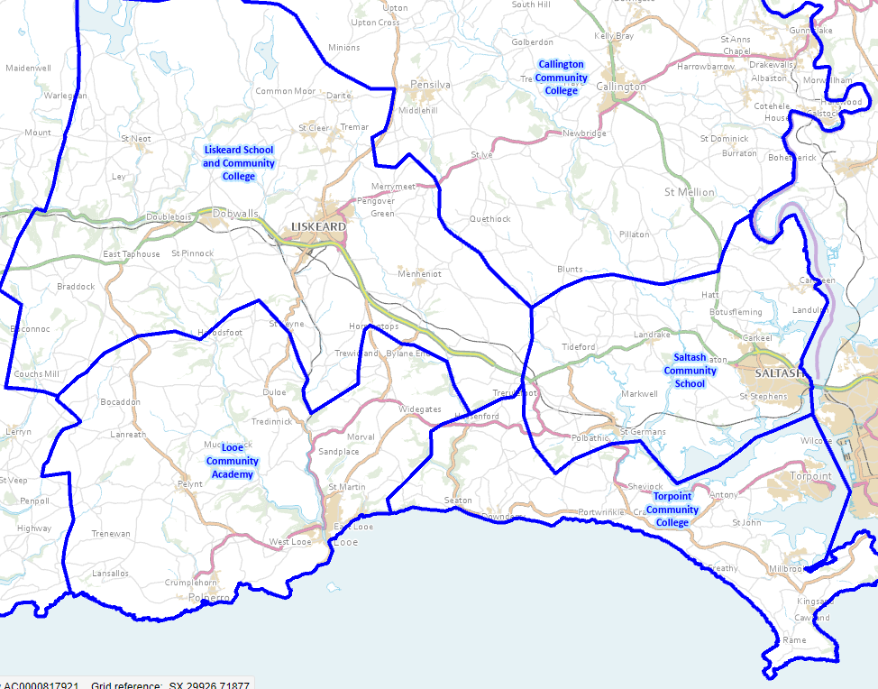
Appendix 1 – Secondary Schools Designated Area

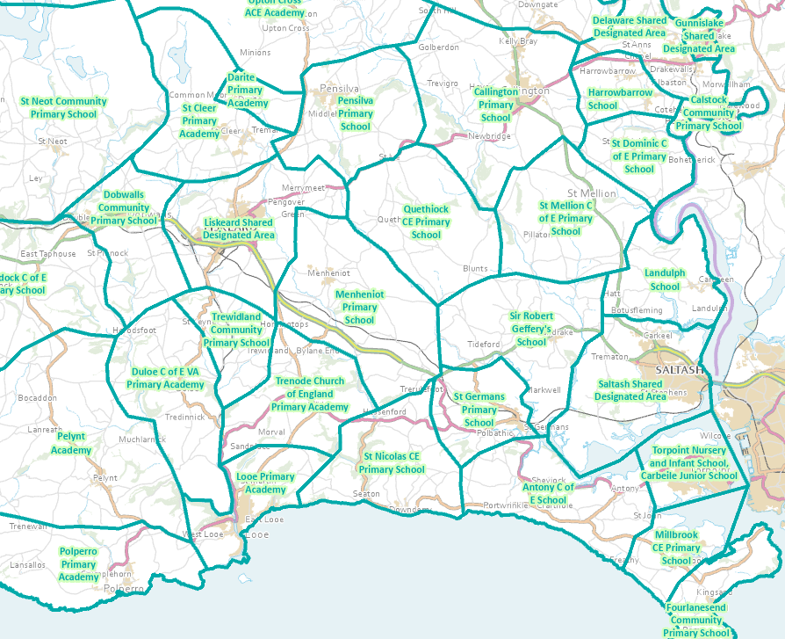 Appendix 2 – Primary Schools Designated Area

Children in care and children who were previously in care A child in care may also referred to as a ‘looked after child’ and is a child who is (a) in the care of a local authority, or (b) being provided with accommodation by a local authority in the exercise of their social services functions (see the definition in Section 22(1) of the Children Act 1989). A Child Arrangement Order is an order settling the arrangements to be made as to the person with whom the child is to live under Section 8 of the Children Act 1989. Section 14A of the Children Act 1989 defines a Special Guardianship Order as an order appointing one or more individuals to be a child’s special guardian (or special guardians). A child is regarded as having been in state care outside of England if they were in the care of or were accommodated by a public authority, a religious organisation, or any other provider of care whose sole or main purpose is to benefit society (see Section 23ZZA(8) of the Children Act 1989 (inserted by Section 4 of the Children and Social Work Act 2017)).

